MINISTRY OF THE WORD

A reading from the Prophet Nehemiah.
. . . all the people gathered together into the square before the Water Gate. They told the scribe Ezra to bring the book of the law of Moses, which the LORD had given to Israel. Accordingly, the priest Ezra brought the law before the assembly, both men and women and all who could hear with understanding. This was on the first day of the seventh month. He read from it facing the square before the Water Gate from early morning until midday, in the presence of the men and the women and those who could understand; and the ears of all the people were attentive to the book of the law. And Ezra opened the book in the sight of all the people, for he was standing above all the people; and when he opened it, all the people stood up. Then Ezra blessed the LORD, the great God, and all the people answered, "Amen, Amen," lifting up their hands. Then they bowed their heads and worshiped the LORD with their faces to the ground. So they read from the book, from the law of God, with interpretation. They gave the sense, so that the people understood the reading. And Nehemiah, who was the governor, and Ezra the priest and scribe, and the Levites who taught the people said to all the people, "This day is holy to the LORD your God; do not mourn or weep." For all the people wept when they heard the words of the law.
Then he said to them, "Go your way, eat the fat and drink sweet wine and send portions of them to those for whom nothing is prepared, for this day is holy to our LORD; and do not be grieved, for the joy of the LORD is your strength." Nehemiah 8:1-3, 5-6, 8-10
Hear the word of the Lord, thanks be to God

The Epistle is from Paul’s first Letter to the Corinthians
For just as the body is one and has many members, and all the members of the body, though many, are one body, so it is with Christ.
For in the one Spirit we were all baptized into one body--Jews or Greeks, slaves or free--and we were all made to drink of one Spirit.
Indeed, the body does not consist of one member but of many.
If the foot would say, "Because I am not a hand, I do not belong to the body," that would not make it any less a part of the body.
And if the ear would say, "Because I am not an eye, I do not belong to the body," that would not make it any less a part of the body.
If the whole body were an eye, where would the hearing be? If the whole body were hearing, where would the sense of smell be?
But as it is, God arranged the members in the body, each one of them, as he chose. If all were a single member, where would the body be?
As it is, there are many members, yet one body. The eye cannot say to the hand, "I have no need of you," nor again the head to the feet, "I have no need of you." On the contrary, the members of the body that seem to be weaker are indispensable, and those members of the body that we think less honorable we clothe with greater honor, and our less respectable members are treated with greater respect; whereas our more respectable members do not need this. But God has so arranged the body, giving the greater honor to the inferior member, that there may be no dissension within the body, but the members may have the same care for one another. If one member suffers, all suffer together with it; if one member is honored, all rejoice together with it. Now you are the body of Christ and individually members of it. And God has appointed in the church first apostles, second prophets, third teachers; then deeds of power, then gifts of healing, forms of assistance, forms of leadership, various kinds of tongues. Are all apostles? Are all prophets? Are all teachers? Do all work miracles? Do all possess gifts of healing? Do all speak in tongues? Do all interpret? But strive for the greater gifts. 1 Corinthians 12:12-31a
May your word live in us, and bear much fruit to your glory

THE GOSPEL

The Lord be with you, and also with you

The Gospel of our Lord Jesus Christ according to Luke 4:14-21

Glory to you Lord Jesus Christ
Then Jesus, filled with the power of the Spirit, returned to Galilee, and a report about him spread through all the surrounding country. He began to teach in their synagogues and was praised by everyone. When he came to Nazareth, where he had been brought up, he went to the synagogue on the sabbath day, as was his custom. He stood up to read, and the scroll of the prophet Isaiah was given to him. He unrolled the scroll and found the place where it was written: "The Spirit of the Lord is upon me, because he has anointed me to bring good news to the poor. He has sent me to proclaim release to the captives and recovery of sight to the blind, to let the oppressed go free, to proclaim the year of the Lord's favor." And he rolled up the scroll, gave it back to the attendant, and sat down. The eyes of all in the synagogue were fixed on him. Then he began to say to them, "Today this scripture has been fulfilled in your hearing."

For the Gospel of the Lord, praise to you Lord Jesus Christ
The New Revised Standard Version (Anglicized Edition), copyright 1989, 1995 by the Division of Christian Education of the National Council of the Churches of Christ in the United States of America. Used by permission. All rights reserved.
WE ASK YOUR PRAYERS THIS WEEK:
For lasting solutions to bring peace to our troubled world: we pray particularly for those parts of the world that are in the news this week. we pray for peace and integrity in all negotiations in international conflicts; and especially for peace in Syria and the Middle East. Hear the cries of the people of Syria; bring healing to those suffering from the violence of Isis and comfort those mourning the dead.

For the sick in our parish, for those listed in the pew sheet, and for those known to us personally
For the faithful departed, remembering those whose years’ mind occurs at this time — May they Rest in Peace and Rise in Glory.

FEBRUARY 3RD 10.30 - COMBINED SERVICE - CHRIST CHURCH LANCEFIELD.
NO SERVICE AT ST PAUL’S ROMSEY ON THAT DAY
PASTORAL VISIT FROM OUR BISHOP The Right Revd. Kate Prowd
Let’s welcome her to our patch with all attending and opportunity to meet with her following the service.

Diary Date: Parish Council meets February 17th @ 12 noon in the Lancefield Hall
Collections
Could you all please save the following items and give to Doreen.
Used stamps – for BCA

Don’t forget Anglicare in your shopping – every bit helps
PARISH DETAILS.
PARISH PRIEST: Rev. Judi Pollard
OFFICE NO: 5429-1830
PARISH PRIESTS MOBILE NO: 0402268001
E-MAIL: judepol@bigpond.net.au
Available by request for baptisms, marriage and funerals
HONORARY ASSOCIATE PRIEST:
Rev. Tom Morgan: 5429-6060
website: www.lancefieldromseyanglican.org
THE ANGLICAN PARISH OF CHRIST CHURCH LANCEFIELD WITH
ST. PAULS’ ROMSEY.
27^{h} January 2019 A.D
3rd Sunday after Epiphany
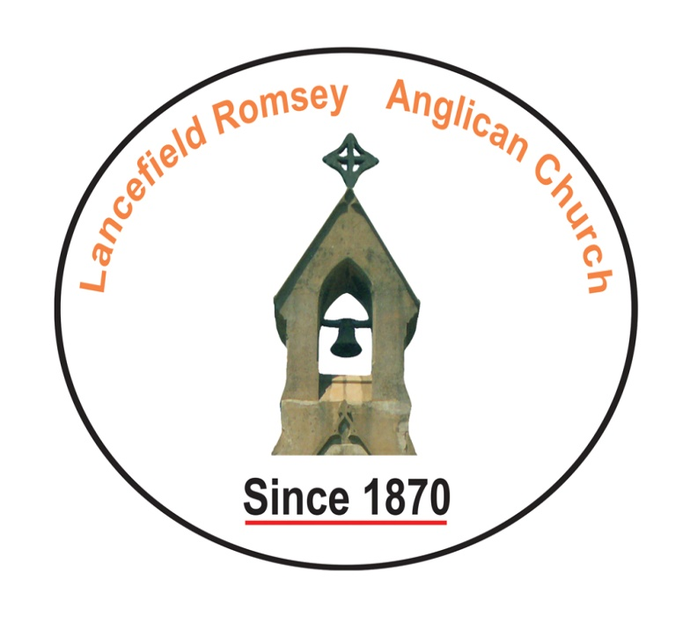
SENTENCE: Jesus read from the Prophet Isaiah: ‘The Spirit of the Lord has anointed me to bring good news to the poor, to proclaim release to the captives.’ Luke 4.18

Prayer for the Day: Life-giving God, who sent your Son Jesus to proclaim your kingdom and to teach with authority: anoint us with your Spirit, that we too may bring good news to the poor, bind up the broken-hearted, and proclaim liberty to the captive; through Jesus Christ our Lord, who lives and reigns with you and the Holy Spirit, one God, now and for ever. Amen.

