MINISTRY OF THE WORD

A reading from the book of genesis..
Joseph said to his brothers, ‘I am Joseph. Is my father still alive?’ But his brothers could not answer him, so dismayed were they at his presence.
Then Joseph said to his brothers, ‘Come closer to me.’ And they came closer. He said, ‘I am your brother Joseph, whom you sold into Egypt. And now do not be distressed, or angry with yourselves, because you sold me here; for God sent me before you to preserve life. For the famine has been in the land these two years; and there are five more years in which there will be neither ploughing nor harvest. God sent me before you to preserve for you a remnant on earth, and to keep alive for you many survivors. So it was not you who sent me here, but God; he has made me a father to Pharaoh, and lord of all his house and ruler over all the land of Egypt. Hurry and go up to my father and say to him, “Thus says your son Joseph, God has made me lord of all Egypt; come down to me, do not delay. You shall settle in the land of Goshen, and you shall be near me, you and your children and your children’s children, as well as your flocks, your herds, and all that you have. I will provide for you there—since there are five more years of famine to come—so that you and your household, and all that you have, will not come to poverty.” And he kissed all his brothers and wept upon them; and after that his brothers talked with him. Genesis 45:311,15
Hear the word of the Lord, thanks be to God
The Epistle is from Paul’s first Letter to the Corinthians
The Resurrection Body
But someone will ask, ‘How are the dead raised? With what kind of body do they come?’ Fool! What you sow does not come to life unless it dies.And as for what you sow, you do not sow the body that is to be, but a bare seed, perhaps of wheat or of some other grain. But God gives it a body as he has chosen, and to each kind of seed its own body. Not all flesh is alike, but there is one flesh for human beings, another for animals, another for birds, and another for fish. There are both heavenly bodies and earthly bodies, but the glory of the heavenly is one thing, and that of the earthly is another. There is one glory of the sun, and another glory of the moon, and another glory of the stars; indeed, star differs from star in glory.
So it is with the resurrection of the dead. What is sown is perishable, what is raised is imperishable. It is sown in dishonour, it is raised in glory. It is sown in weakness, it is raised in power. It is sown a physical body, it is raised a spiritual body. If there is a physical body, there is also a spiritual body. Thus it is written, ‘The first man, Adam, became a living being’; the last Adam became a life-giving spirit. But it is not the spiritual that is first, but the physical, and then the spiritual. The first man was from the earth, a man of dust; the second man is from heaven. As was the man of dust, so are those who are of the dust; and as is the man of heaven, so are those who are of heaven. Just as we have borne the image of the man of dust, we will also bear the image of the man of heaven.
What I am saying, brothers and sisters, is this: flesh and blood cannot inherit the kingdom of God, nor does the perishable inherit the imperishable.
1 Corinthians 15: 35-50
May your word live in us, and bear much fruit to your glory
THE GOSPEL

The Lord be with you, and also with you
The Gospel of our Lord Jesus Christ according to Luke 6: 27-38

Glory to you Lord Jesus Christ
Love for Enemies
‘But I say to you that listen, Love your enemies, do good to those who hate you, bless those who curse you, pray for those who abuse you. If anyone strikes you on the cheek, offer the other also; and from anyone who takes away your coat do not withhold even your shirt. Give to everyone who begs from you; and if anyone takes away your goods, do not ask for them again. Do to others as you would have them do to you.
‘If you love those who love you, what credit is that to you? For even sinners love those who love them. If you do good to those who do good to you, what credit is that to you? For even sinners do the same. If you lend to those from whom you hope to receive, what credit is that to you? Even sinners lend to sinners, to receive as much again. But love your enemies, do good, and lend, expecting nothing in return. Your reward will be great, and you will be children of the Most High; for he is kind to the ungrateful and the wicked. Be merciful, just as your Father is merciful.
Judging Others
‘Do not judge, and you will not be judged; do not condemn, and you will not be condemned. Forgive, and you will be forgiven; give, and it will be given to you. A good measure, pressed down, shaken together, running over, will be put into your lap; for the measure you give will be the measure you get back.’
For the Gospel of the Lord, praise to you Lord Jesus Christ

WE ASK YOUR PRAYERS THIS WEEK:
For lasting solutions to bring peace to our troubled world: we pray particularly for those parts of the world that are in the news this week. we pray for peace and integrity in all negotiations in international conflicts; and especially for peace in Syria and the Middle East. Hear the cries of the people of Syria; bring healing to those suffering from the violence of Isis and comfort those mourning the dead.

For the sick in our parish, and for those known to us personally
For the faithful departed, remembering those whose years’ mind occurs at this time — May they Rest in Peace and Rise in Glory.

Collections
Could you all please save the following items and give to Doreen.
Used stamps – for BCA

Don’t forget Anglicare in your shopping – every bit helps...

PARISH DETAILS.
PARISH PRIEST: Rev. Judi Pollard
OFFICE NO: 5429-1830
PARISH PRIESTS MOBILE NO: 0402268001
E-MAIL: judepol@bigpond.net.au
Available by request for baptisms, marriage and funerals
HONORARY ASSOCIATE PRIEST:
Rev. Tom Morgan: 5429-6060
website: www.lancefieldromseyanglican.org
THE ANGLICAN PARISH OF CHRIST CHURCH LANCEFIELD WITH
ST. PAULS’ ROMSEY.
24th February 2019 A.D
7thSunday after Epiphany
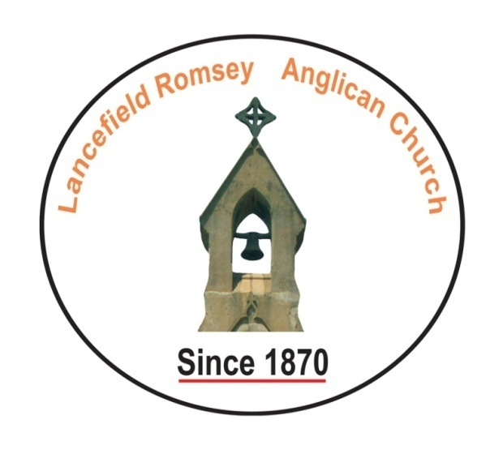
SENTENCE:
In the Son of God, Jesus Christ, every one of God’s promises finds its “yes”. 2 Corinthians 1:1-19
Prayer for the Day:
Almighty God,
In signs and wonders
Your son revealed the greatness of your saving love:
Renew your people with your grace,
And sustain us by your power,
For we can do nothing good without you;
Through Jesus Christ our Lord,
Who is alive and reigns with you and the Holy Spirit,
One God, now and for ever. Amen.

