PRAYER
- Pray for renewed commitment to prayer throughout our Diocese.
- Pray for the work of BCA in Australia.
- Pray for those unwell or in distress at this time, especially Doreen, Jean, Anna, Shirley, Carol and Cath.
- Pray that all politicians will deal
compassionately with refugees and seek a solution that reflects Jesus' love for us all. Pray that nations and individuals will compassionately give.
- Give thanks our doctors
- Pray that God is the centre of families and marriages and his presence is felt.
- Give thanks and pray for the work of
Anglicare and the groups they support and who support them.
- Pray for the all the little children suffering illness that they and their families find strength and peace.
- Pray for those affected by Mother Nature around the world, pray for peace and calm and healing in all places.
- pray for the safety of the emergency and armed services personnel
- Pray for the families who have lost loved ones that they may feel God's caring hand on their hearts.
- Pray for peace, calm unity and clarity in Australia and overseas.

Prayer of the day
Loving God, your Son came to seek the lost, and was baptised with sinners:
Grant that we, who have been baptised in his name, may reach out in love to those in need with the mercy of Christ our Lord, who lives and reigns with you, for ever and ever.
Amen.

Parish Prayer
Heavenly Father, empower us by your Holy Spirit to do your will. Visibly strengthen us to reach out in Christ to others through prayer, worship, study, fellowship, and service, enabling us to share your word and peace.
Help us to grow in love, faith and obedience as we discover meaning, purpose and direction for today and hope for tomorrow through Jesus Christ our Lord. Amen

PARISH DETAILS.
PARISH PRIEST: Rev. Judi Pollard
OFFICE NO: 5429-1380
PARISH PRIESTS MOBILE NO: 0402268001
E-MAIL: judepol@bigpond.net.au
Available by request for baptisms, marriage and funerals
HONORARY ASSOCIATE PRIEST:
Rev. Tom Morgan: 5429-6060
(Pew Leaflet by Tuesday to Robyn Cozens)
Ph: 54293429
Email: donegal_consulting@hotmail.com
website: www.lancefieldromseyanglican.org

THE ANGLICAN PARISH OF CHRIST CHURCH LANCEFIELD WITH
ST. PAULS’ ROMSEY.

“Connecting with God and our community.”
"Do what's right and God will do what's left"

13th January 2019 A.D
1st Sunday after Epiphany

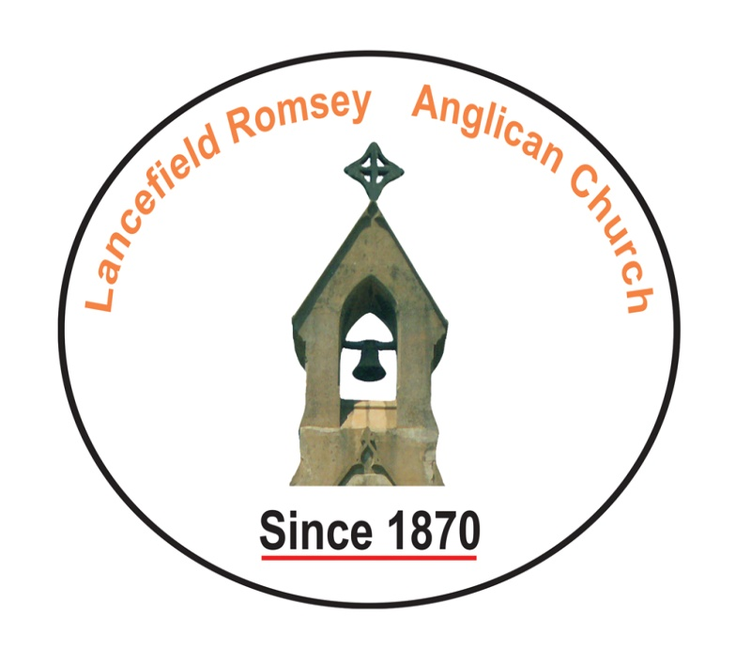
We are glad you are with us.
Before the service, speak to the Lord in prayer
During the service, let the Lord speak to you
After the service, speak to one another

Sentence of Scripture:
The Holy Spirit descended on Jesus in bodily form like a dove, and a voice came from heaven, “You are my Son, the Beloved: with you I am well pleased.” Luke 3:22
BIBLE READING
1st Reading Isaiah 43:1-7
Small print: Page 514
Large Print: Page 1126
Romsey Reader: Elaine Lobb
Lancefield reader: volunteer
2nd Reading: Acts 8:14-17
Small Print: Page 776
Large Print: Page 1703
Romsey reader: Glenice Mitchell
Lancefield reader: Volunteer
Gospel Reading Luke 3:15-22
Reader Rev

READINGS FOR NEXT WEEK
SUNDAY 20th January 2019
2nd Sunday after Epiphany
1st Reading Isaiah 62:1-5
Small print: Page 529
Large Print: Page 1159
Romsey Reader: Laurie Thomson
Lancefield reader: volunteer
2nd Reading: 1 Corinthians 12:1-11
Small Print: Page 813
Large Print: Page 1785
Romsey reader: Winifred Mills
Lancefield reader: Volunteer
Gospel Reading John 2:1-11
Reader Rev
ABM Pew Reflection
In Baptism, Christ knits us all together into his body and in doing that we become a part of him here on earth. The Christian life is one in which we are called to follow Christ in everything that we do, and it’s our belief that in us God will recognise Christ. When the Holy Spirit descends upon Jesus in his baptism by John the Baptist, the voice comes from heaven saying, ‘You are my son, the Beloved; with you I am well pleased’. In our baptisms as well as in our lives we can expect that God says much the same that we are his beloved children and with us he is pleased.
- Pray that God may direct you towards new ways of life to live more closely to him and be more pleasing to him.
- Give thanks for the Anglican Church of Australia, and pray that in each of the dioceses God’s love for the world may be made known.
Text: The Rev Will Johnston,
© Anglican Board of Mission, 2019

Collections
Could you all please save the following items and give to Doreen.
Used stamps – for BCA

Don’t forget Anglicare in your shopping – every bit helps

DIARY DATES
Romsey - 8.45 Prayers.
9·ooam service
Lancefield - 10.15am prayer
10.30am service

Tuesday 15th January.
In Recess until further notice
10.00am -. Bible Study at Lancefield. We are new looking at the problems arising in the fledgling church in Galatia. An area in to which the Romans herded the troublesome Celtic clans into.

